Adding of two numbers without using + operator.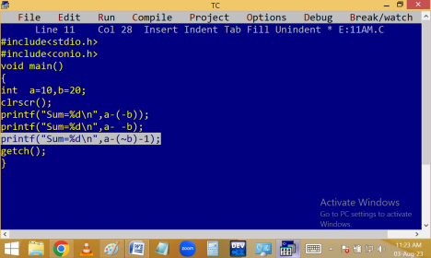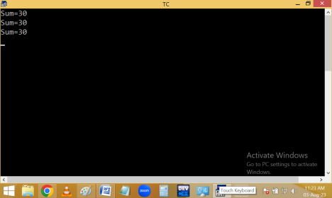
Swap of two numbers [ interchange ]:
Without using operators:
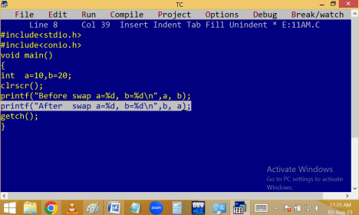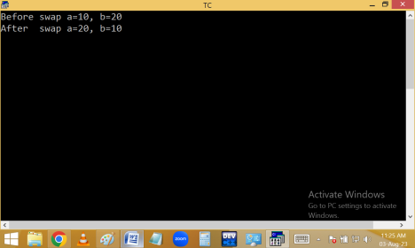
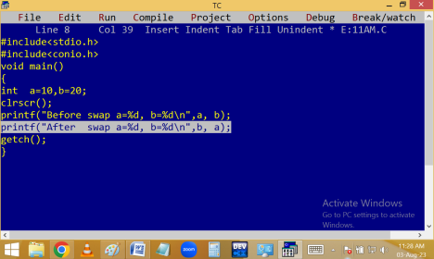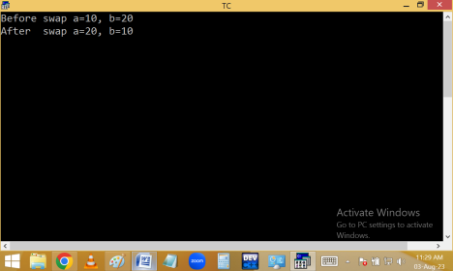
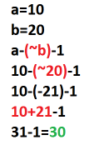
Method 2 using 3rd variable:
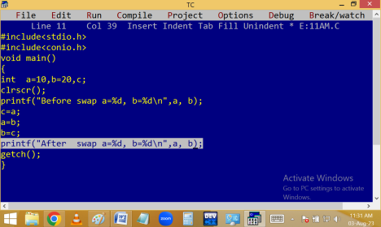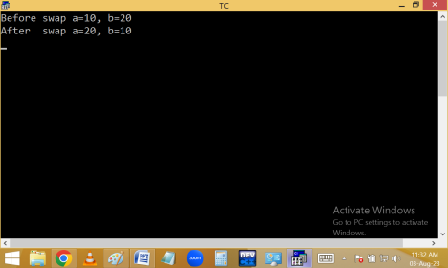
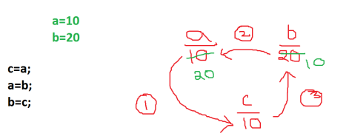Without using 3rd variable:
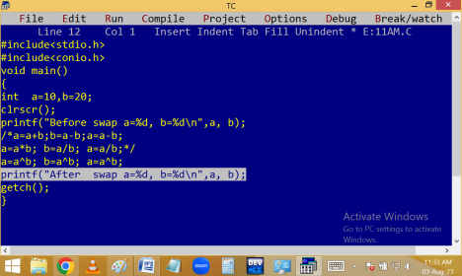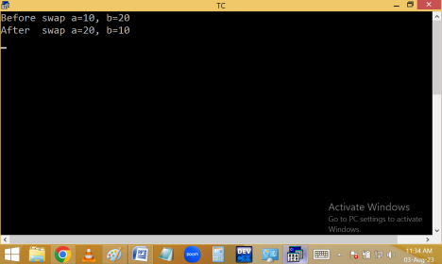
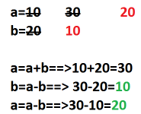
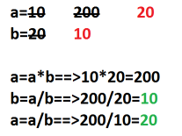
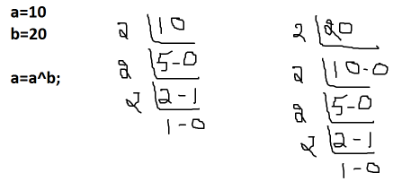
We are having 2 types of variables.
1. Local variables
2. Global variables
 | Local variables | Global variables
Declaration | Within function | Top of the program
Storage area | Stack area | Data area
Initial values | Garbage | Int-0, float-0.000000 Char-blank
Scope – where we can use | Within function | Total program
Life time – until what time they are in memory | Up to execution of that function | Up to total program execution

Finding initial values of local and global variables:
Finding local and global address:
Finding scope of a local variable[ where we can access]:
Finding scope of a global variable:
Finding life time of a local variable:
Finding life time of a global variable:
Note: When local and global variables with same name, always prority goes to local variable.

